SHUT DOWN CHECKLIST
1) OPEN ALL CABINET, SHOWER DOORS AND CLOSETS
2) CLOSE DRAPES AND BLINDS
3) TAKE IN OUTSIDE FURNITURE
4) EMPTY FRIDGE & FREEZER OF ANY FOODS THAT MAY PERISH IF POWER IS LOST
5) LOWER FRIDGE TEMPERATURE (DO NOT TURN DOWN FREEZER TEMP)
6) TURN OFF ICE MAKER AND REMOVE ICE.
7) POUR 2 ozs OF VEGETABLE OIL DOWN DISPOSAL
8) TURN OFF VALVE BELOW EACH TOILET
9) TURN OFF WASHING MACHINE HOSE CONNECTIONS
10) MAKE SURE ALL WATER FAUCETS ARE CLOSED
11) SHUT CIRCUIT BREAKER FOR HOT WATER HEATER
12) TURN OFF MAIN WATER ( ¼ TURN AND EITHER REMOVE HANDLE (LEAVE HANDLE
IN CONSPICUOUS INSIDE SPOT FOR HOME WATCH OR PLACE A LOCK
ON THE VALVE (See below for recommended lock*). THIS PREVENTS OUTSIDE CONTRACTORS FROM
USING/INADVERTENTLY LEAVING WATER ON.
13) REPLACE BATTERIES IN AIR CONDITIONER CONTROL BOX
14) SET A/C THERMOSTAT NO HIGHER THEN 78* AND PUT ON “HOLD).
OPTIONS
LEAVE CEILING FAN/FANS ON LOW SPEED FOR AIR CIRCULATION
ENSURE AIR CONDITIONER CONDENSER DRAIN LINES ARE CLEAR AND FREE OF DEBRIS.
CHANGE AIR CONDITIONER FILTER - TURN OFF RADON FAN ( IF APPLICABLE )
PUT A SMALL BOWL OF ICE IN THE FREEZER. IF THE CUBES HAVE NOT MELTED WHEN YOU RETURN...YOUR FOOD IS GOOD.
RE-OPENING WATER SUPPLY
1) ENTER HOME AND OPEN A MINIMUM OF 2 FAUCETS
2) OPEN OUTSIDE MAIN WATER SHUTOFF SLOWLY. THIS WILL INSURE THAT THERE IS NO SUDDEN PRESSURE SURGE THAT MIGHT BURST INTERNAL PIPES.
3) RESET ABOVE SHUT DOWN LIST
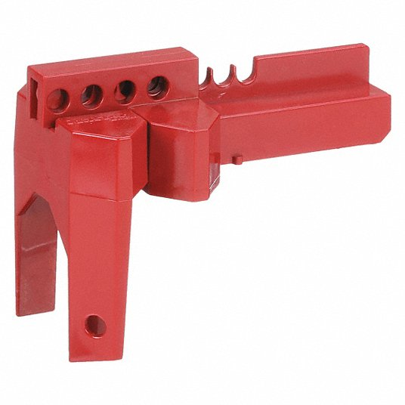
Master Lock Ball Valve
Model S3081
Available: Lowes/Home Depot/Amazon
Approximate cost: $20 plus inexpensive lock

